# Recommended Settings for PF850 COM port.

Open up the device manager and then connect the usb cable between PF850 and PC. See which COM port is created. Refer to the PureFocus 850 installation manual for further details on installing USB drivers.

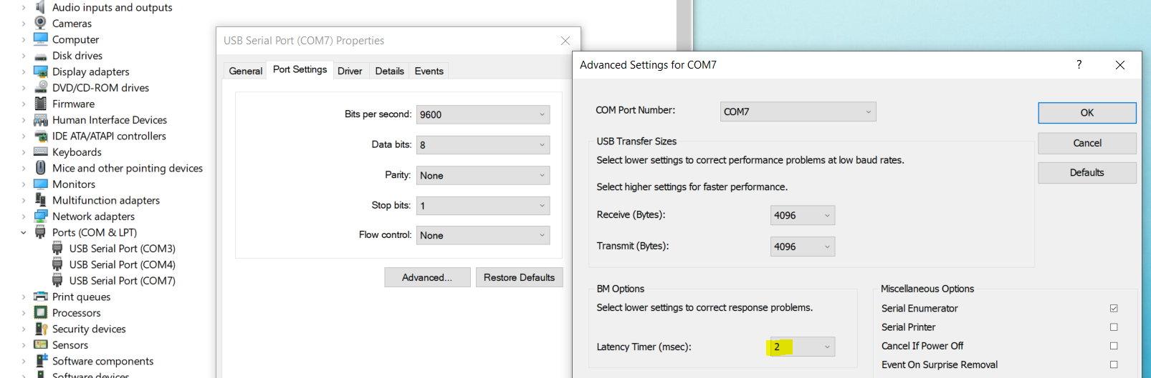

For best performance make sure that the latency timer (highlighted) is set to 2ms in the Advanced Settings of the COMx port properties the Pf850 is on.

Start ‘PriorTerminal.exe’, click on COM and select required COMx and select baud rate of 460800.

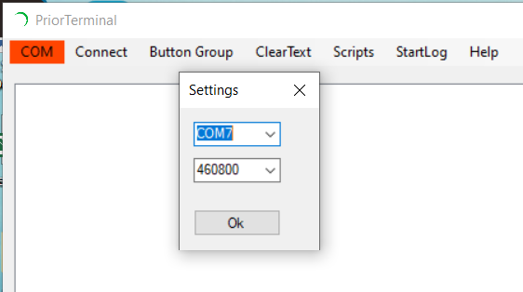

Test connection by entering *DATE* command and pressing enter.

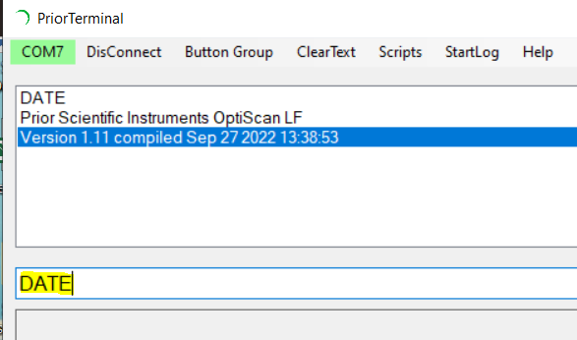

# Upgrading the FPGA code

From the ‘controller’ sub-folder run the *LF_sflash.exe* application. Enter the com port number the PF850 is using. If the port is ‘COM7’ enter just the value 7. This port can obtained from the dev manager as shown above.

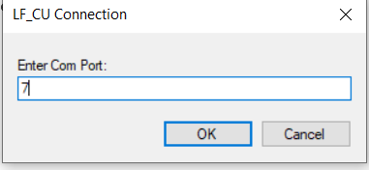

Press ‘Program Serial Flash’ button to re-program FPGA on your PF850. This may take several minutes!

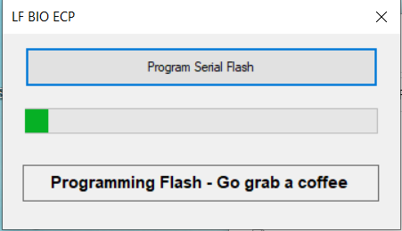

Do not power cycle controller during the programming.

When finished close the application and power cycle the controller.

# Upgrading Controller Firmware

From the ‘controller’ sub-folder run the *LF UpgradeTool.exe* application to re-flash the controller firmware. This application will automatically scan the first 16 COM ports and will upgrade the first PF850 unit it finds.

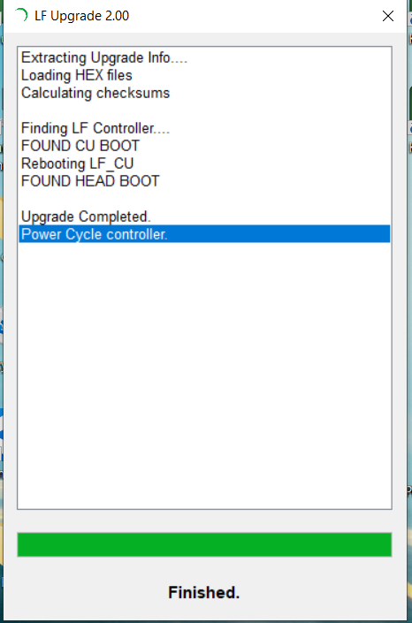

When finished close the application and power cycle the controller.

Re-connect the terminal and check the updated DATE command response.